January | 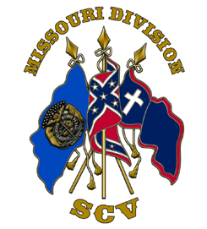
 | 2023
Sunday | Monday | Tuesday | Wednesday | Thursday | Friday | Saturday
1 | 2 | 3 | 4 | 5 | 6 | 7
 | Coffee Camp Meeting  Osceola 6:00PM |  | Gates Camp Meeting  Auxvasse 6:00PM
8 | 9 | 10 | 11 | 12 | 13 | 14
Price Camp Meeting  Pacific 2:00PM  Brooks Camp Meeting  Cooter 3:30PM |  |  |  | Hughes Camp Meeting  Buckner 7:00PM  McBride Camp Meeting  Springfield 6:00PM |  | Utz Camp Meeting  9:00AM
15 | 16 | 17 | 18 | 19 | 20 | 21
 | Cravens Camp Meeting  Gallatin 7:00PM  Camp Livingston  Meeting and Dinner 6:00 | Campbell Camp Meeting Billings 7:00PM |  | Robert E Lee Birthday  1807 | Parsons Camp Meeting  Lohman 5:30PM | Thomas Jackson Birthday 1824  Lee/Jackson Dinner Rolla ??
22 | 23 | 24 | 25 | 26 | 27 | 28
Camp Livingston Joplin Gun Show
Stoddard Camp Meeting
2:00PM
29 | 30 | 31
Camp Livingston Gun Show

